

Draw It of Lose It

# **CS 230 Project Software Design Template**

Version 1.1

## Table of Contents

**CS 230 Project Software Design Template**1

**Table of Contents**2

**Document Revision History**2

**Executive Summary**3

**Design Constraints**3

**System Architecture View**3

**Domain Model**3

**Evaluation**3

**Recommendations**5

## Document Revision History

| Version | Date | Author | Comments |
| --- | --- | --- | --- |
| 1.0 | 09/19/20 | Karac Shamberger | Updating Executive summary, design constraints and domain model. |
| 1.1 | 10/4/2020 | Karac Shamberger | Providing recommended operating system with provided information |

**Instructions**

Fill in all bracketed information on page one (the cover page), in the Document Revision History table, and below each header. Under each header, remove the bracketed prompt and write your own paragraph response covering the indicated information.

## Executive Summary

The client is looking to expand their gaming application. As part of this expansion they are looking to develop a web-based game service that serves multiple platforms. The client would like us to set up the environment to facilitate the development of their web-based version. We will also develop the game application to meet their software requirements. Their current mobile application is only available Android. The client requires that a game will have the ability to have one more team involved, each team will have multiple players, the names of the game and the team must be unique so that users are able to check whether a name is in use and only one game can exist in the memory at any given time.

## Design Constraints

The game application is to developed so that the application is able to be used on various web-based platforms. The client’s mobile application is only available on Android. The client requires that all team names be unique, this will require a sizeable amount of storage. We will need to discuss the storage requirements for the database.

## System Architecture View

Please note: There is nothing required here for these projects, but this section serves as a reminder that describing the system and subsystem architecture present in the application, including physical components or tiers, may be required for other projects. A logical topology of the communication and storage aspects is also necessary to understand the overall architecture and should be provided.

## Domain Model

When looking at the below UML diagram we have three classes, “Game”, “Team” and “Player”. All three of the classes have a “is a” relationship with “Entity”. The classes “Game”, “Team” and “Player” are all inherited from “Entity”. The three classes are share common attributes.

When looking at the relationship between “Game”, “Team” and “Player” they all have a “has a” relationship with one another. When having a “has a” relationship it means that the classes reference each other. In the UML diagram Encapsulation is used in the “Entity” class to help secure information.

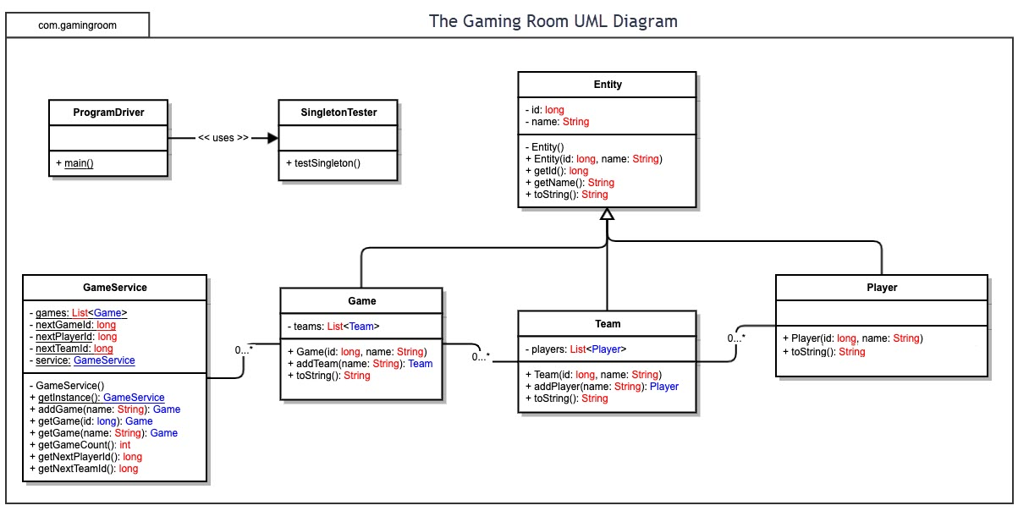

## Evaluation

Using your experience to evaluate the characteristics, advantages, and weaknesses of each operating platform (Linux, Mac, and Windows) as well as mobile devices, consider the requirements outlined below and articulate your findings for each. As you complete the table, keep in mind your client’s requirements and look at the situation holistically, as it all has to work together.

In each cell, remove the bracketed prompt and write your own paragraph response covering the indicated information.

| **Development Requirements** | **Mac** | **Linux** | **Windows** | **Mobile Devices** |
| --- | --- | --- | --- | --- |
| **Server Side** | **Pros**: Mac OS provides a very easy and streamline process to configure a server. Affordable cost for license and will cover Mac OS and IOS. The Mac OS is less vulnerable to malware. Mac Os will provide cloud storage between Mac OS and IOS.  **Cons**: If user is unfamiliar with OS can cause troubles navigating / useability when creating server. Some major software and hardware packages are not certified for the MacOS, no available support for said hardware and software. Scalability is limited and will require in-depth knowledge of the OS (not ideal for enterprise operations) | **Pros:** When it comes to freedom a Linux based server will provide you with the greatest amount. Being free, and open-source the cost is great. Majority of software is able to be run of Linux. Very simple server configuration. Scalability. Linux servers are very cheap  **Cons:** Similar to MacOS, Linux requires familiarity with the OS to be effective, there is a steep learning curve to Linux. Since windows is the most used OS, Linux cannot run windows programs. Since Linux is open source you may run into problems that you cannot fix easily or without professional help. | **Pros:** Most used OS, familiarity/ useability. Windows provides a great support option to their servers. Almost all software is able to be used with windows. With Windows being such a massive world-wide company, the integration is great between all windows-based computers and software packages.  Report support, able to provide remote desktop support.  **Cons:** Windows servers are more susceptible to malware. A Windows server license is more expensive than a Mobile and Linux server license. | **Pros:** Very cheap  **Cons:** Very hard to make compatible games work on IOS and Android. |
| **Client Side** | **Pros:** User face is streamed lined once user acquires skills to operate. Great graphics interface. The client will be less exposed to malware.  **Cons:** Greater skills than Windows to normally operate MacOS. Most expensive out of compared operating systems. | **Pros:** Minimum cost out of all compared operating systems (open source). Linux OS naturally has a better security prevention than Windows.  **Cons:** Greater skills than MacOS and Windows to navigate through Linux. Least amount of support. | **Pros:** Users ease of use (most users are familiar with Windows). Clients will have the widest range of software available to them  **Cons:** More expensive than Linux. Clients will be more exposed to malware, almost all malware is designed to go after Windows operating systems. | **Pros:** Strong security and resistant to malware. User interface is very user friendly.  **Cons:** Mobile platform very difficult to utilize application created on different platforms. Expensive to run. Overall quality is limited. |
| **Development Tools** | All main stream software systems are able to be run on Mac OS. For example, Java, Python, C++, etc. For the above software you are able to run Eclipse, Visual Studio, online dev tool, etc. The installation of the above software can be harder to install compared to Windows OS. | With Linux being open source, it can run all main stream software systems and it can also run “non main steam” software such as Ruby on Rails. Linux can also utilize Github, node.js as well as Eclipse and Visual Studios. | All main stream software systems are able to be run on Mac OS. For example, Java, Python, C++, etc. For the above software you are able to run Eclipse, Visual Studio, online dev tool, etc. Installing on Windows will be easier than Mac OS and Linux. | Mobile applications are able to run HTML, C++, Python, etc. For developing mobile applications IDE include Visual Studio, Eclipse, Repl.it and more |

## Recommendations

Analyze the characteristics of and techniques specific to various systems architectures and make a recommendation to The Gaming Room. Specifically, address the following:

1. **Operating Platform**: After researching and creating the above list and also taking into considerations of the server requirement, client requirements and developer tools requirements I would recommend the Window OS to expand The Gaming Room future capabilities. While using the Windows OS, The Gaming Room will be able to interface with all major servers and clients because Windows OS provides web server (The Gaming Rooms’ ask), file server, database server (to store username and passwords) and much more.
2. **Operating Systems Architectures**: Windows server operating system architectures is a layered design that consists of two main components a user mode and kernel mode. Having this architecture in place allows the operating system to be able to run application written for different operating systems. With multi-processor scheduling utilized, Windows server provides optimal application performance on machines with many processors.
3. **Storage Management**: Windows operating system allows multiple ways for data to be stored and saved. Firstly, Windows memory is very easily upgraded to have more space via a HDD or a SDD. A SDD would be my recommendation. Another way Windows allows for storage management is transferring data to another computer or server to free up space.
4. **Memory Management**: Windows memory management is offered in multiple ways. The Widows operating contains RAM, physical memory and virtual memory space. The virtual memory or pagefile for Windows allows the computer to perform better by reducing the workload of the physical and or RAM.
5. **Distributed Systems and Networks**: For Draw it or Lose it to communicate between various platforms we will be using the Client-Server distributed system. When using distributed systems and network it offers a very simple way of communication between different workstations. One of Draw It or Lose It requests is to have their game be web-based and by using distributed systems and networks we will be able to achieve this goal.
6. **Security**: Using the Windows operating system, it provides built in security layers that will help prevent unauthorized access as well as keeping private information safe. Windows Defender is a built-in application and comes in two different flavors. The first, Windows Defender Device Guard which protects against malicious code. Second, Windows Defender Credential Guard that only allows privileged systems and software to access data. To only allows the correct privileged systems and software Windows Defender verifies a user’s credentials before granting access to any information.